**A PROJECT REPORT**

**ON**

**POLICE DUTY SCHEDULING**

Submitted in partial fulfillment for the award of **Post Graduate Diploma in Advance Computing (PG-DAC) from**

**INSTITUTE OF EMERGING TECHNOLOGIES**

**Authorized Training Centre**



**Under the Guidance of Mr. Ravi Tambade**

**BY**

**Mr. SHUBHAM LOKHANDE (230945920053)**

**Mr. SAURABH KHARTUDE (230945920044)**

**Mr. ROHIT SHENDE (230945920093)**

**Mr. JAI PATANKAR (230945920033)**

**Mr. SHAILESH PATIL(230945920067)**



**CERTIFICATE**

This is to certify that the project report entitled **Uniguide** is a bonfire work carried out by **Mr. Shubham Lokhande, Mr. Saurabh Khartude, Mr. Rohit Shende, Mr. Jai Patankar, Mr. Shailesh Patil** and submitted in partial fulfilment of the requirement for the C-DAC ACTS, DAC course in Institute of Emerging Technology in the batch of September 2023.

**Course Co -ordinator** **External Examiner**

**Mr. Manoj Deshmukh Mr. Ravi Tambade**

ACKNOWLEDGEMENT

This project **Police Duty Scheduling** was a great learning experience for us and we are submitting this work to Advanced Computing Training School (CDAC).

We are very glad to mention **Mr.Ravi Tambade** for his valuable guidance to work on this project. Her guidance and support helped us to overcome various obstacles and intricacies during project work.

Our most heart full thanks go to ***Mr. Sangram Patil* (Director, IET)** who gave all the required support and kind coordination to provide all the necessities like required hardware, internet facility and extra lab hours to complete the project and throughout the course up to the last day here in C-DAC ACTS, Pune.

Sign of student

**Shubham Lokhande**

**(230945920053)**

**Saurabh Khartude**

**(230945920044)**

**Rohit Shende**

**(230945920093)**

**Jai Patankar**

**(230945920033)**

**Shailesh Patil**

**(230945920067)**

**Abstract**

The Police Duty Scheduling System is a project designed to streamline and automate the process of scheduling police officers within law enforcement agencies. Efficient management of police duty schedules is critical for maintaining public safety, ensuring proper coverage, and preventing officer fatigue. This project focuses on developing a user-friendly and efficient system that leverages technology to simplify the scheduling process, taking into account various factors such as officer availability, preferences, and organizational requirements.

The system was developed using an agile software development approach, which allowed for iterative development and continuous feedback from stakeholders. The project team used various tools and technologies such as Java EE, MySQL, ReactJS, JavaScript, and HTML/CSS to build the system.

The project report provides a detailed overview of the system's design, development, testing, and deployment processes. It also discusses the challenges faced during the project and the lessons learned, along with recommendations for future improvements. Overall, the car service management system project report serves as a valuable resource for businesses looking to streamline their car servicing operations and enhance customer experience.

**Index**

|  |  |  |
| --- | --- | --- |
| **Sr. No.** | **Title** | **Page No.** |
| **1** | Introduction | 6 |
| **2** | Problem Definition & Scope | 7 |
| **2.1** | Problem Definition | 7 |
| **2.2** | Goals & Objectives | 8 |
| **2.3** | Major Constraints & Outcomes | 9 |
| **3** | Software Requirement Specification | 11 |
| **3.1** | Proposed System | 12 |
| **3.2** | Scope | 12 |
| **4** | Performance-Requirements | 16 |
| **4.1** | H/W Requirements | 16 |
| **4.2** | S/W Requirements | 16 |
| **5** | UML Diagram | 17 |
| **5.1** | DFD | 18 |
| **5.2** | ERD | 20 |
| **5.3** | Class Diagram | 21 |
| **5.4** | Sequence diagram | 22 |
| **5.5** | Activity Diagram | 23 |
| **5.6** | Deployment diagram | 24 |
| **6** | Screenshots | 25 |
| **7** | Conclusion | 33 |

**INTRODUCTION**

# The Web-Based Police Duty Scheduling project is a modern solution designed to revolutionize the way law enforcement agencies manage and organize officer duty schedules. This online platform leverages the power of the web to provide a user-friendly interface for efficient scheduling, enabling administrators to streamline the allocation of shifts while considering officer availability and organizational requirements. By transitioning from manual to web-based scheduling, this project aims to enhance flexibility, reduce administrative burden, and optimize the deployment of police personnel, ultimately contributing to improved operational effectiveness and officer well-being.

# 2.PROBLEM DEFINITION & SCOPE

**1.Duty Repetition to Single Policemen:**

In an offline duty assigning system using registers, the manual nature of the process increases the likelihood of duty repetition for a single policemen.

Lack of visibility into historical duty assignments can lead to inadvertent scheduling errors, resulting in officers being assigned the same duties frequently.

**2.Data is Not Getting Stored Digitally:**

The register-based system relies on physical records, making it susceptible to damage, loss, or unauthorized access.

Lack of digital storage prevents efficient data retrieval, analysis, and reporting, hindering the ability to track duty histories, trends, and performance metrics.

**3.Manual Duty Assigning System is Confusing and Complicated:**

The manual process of duty assignment using registers can be prone to human errors, leading to confusion and complications.

Officers and administrators may find it challenging to navigate through handwritten entries, increasing the risk of mistakes in duty assignments.

**4.Offline Duty Scheduling System is Time-Consuming:**

The manual nature of the offline duty scheduling system is time-consuming, requiring administrators to manually review and update duty assignments.

Time spent on manual scheduling could be better utilized for strategic planning, training, or addressing other critical tasks within the law enforcement agency.

**5.Register-Based System Not Available Globally:**

The traditional register-based system may not be universally accessible or compatible with the evolving technological landscape.

Law enforcement agencies with diverse infrastructures or operating in different regions may face challenges in implementing a standardized register-based system globally.

**Scope of Project**

The future scope of the Web-Based Police Duty Scheduling Project involves several avenues for improvement and expansion. One key aspect is the integration of more advanced reporting and analytics features, allowing law enforcement agencies to derive valuable insights from historical scheduling data. Enhanced reporting capabilities could aid administrators in making informed decisions about resource allocation, identifying trends, and optimizing scheduling processes. Additionally, exploring the implementation of biometric authentication and mobile verification could add an extra layer of security to the system, ensuring the integrity and confidentiality of duty schedules. The project can also explore the facilitating the efficient handling of officer requests for time off and minimizing disruptions in duty schedules. As technology advances, the project should stay adaptable to new web-based frameworks and technologies, ensuring continued compatibility and accessibility across various devices and platforms. Regular user feedback and collaboration with law enforcement professionals will be crucial for refining the system to meet the unique and evolving needs of different agencies, ultimately contributing to improved operational efficiency and officer satisfaction.

## Goals&Objectives

## Goals:

**1.Automation**: Implement an automated scheduling system to streamline duty assignments and minimize manual effort.

**2.Digital Management**: Establish a secure digital database for efficient data storage, retrieval, and analysis.

3**.Real-time Updates**: Provide features for real-time updates and notifications to enhance communication and responsiveness.

**4.Compliance:** Ensure compliance with labor regulations, union agreements, and organizational policies.

**5.Time Efficiency**: Reduce manual scheduling time, allowing administrators to allocate time strategically.

**6.Global Accessibility**: Design a universally accessible system for law enforcement agencies worldwide.

## Objectives:

1.Transparency: Foster transparency in duty assignments by providing a clear and accessible system that allows both administrators and officers to easily understand and access their schedules.

2.Adaptability: Develop a system that can adapt to dynamic operational needs, allowing for quick adjustments in response to emergencies, unforeseen events, or changes in officer availability.

3.Compliance: Ensure compliance with labor laws, union agreements, and organizational policies regarding working hours, overtime, and rest periods, reducing the risk of legal issues.

4. Communication: Facilitate effective communication within the law enforcement agency by providing real-time updates and notifications regarding changes in duty schedules or other relevant information.

5. Officer Satisfaction: Improve officer satisfaction by considering preferences and creating fair and balanced duty schedules, contributing to a positive working environment.

6. Resource Optimization: Optimize the allocation of police personnel to prevent issues like fatigue and burnout, ultimately enhancing the agency's ability to maintain public safety.

**Major Constraints & Outcomes**

**Police Duty Scheduling can have several constraints and outcomes, including:**

**Constraints:**

* + 1. **Technology:** The system relies heavily on technical glitches or issues can impact the system's effectiveness.
    2. **Internet connectivity:** Police Duty Scheduling system requires a stable and reliable internet connection, which can be a challenge in some areas.
    3. **Data security:** With sensitive customer and financial data being stored online, data security is a major concern for online car service station management systems.
    4. **User adoption:** The system may not be as effective if it is not adopted by all police stations, including mechanics and administrative staff.
    5. **Integration with Police stations:** Building partnerships with police stations and accessing their data for matching purposes might face resistance or technical challenges due to differing systems and policies.

**Outcomes:**

1) **Optimal Workforce Utilization**: Maximizing the use of available personnel to meet

operational needs efficiently.

2) **Employee Satisfaction**: Designing schedules that take into account officer preferences and work-life balance to enhance job satisfaction.

1. **Reduced Overtime Costs**: Minimizing the need for overtime by creating efficient duty schedules.

4) **Improved Performance and Safety**: Ensuring that officers are not overworked to maintain high levels of alertness, performance, and overall safety.

5) **Adaptability and Flexibility**: Creating a scheduling system that can adapt to changes in staffing requirements or unexpected events.

6) **Compliance and Accountability:** Ensuring that the scheduling system complies with legal regulations and department policies, and holding administrators accountable for any deviations.

7) **Enhanced Communication**: Facilitating effective communication between officers and scheduling administrators to address concerns and changes promptly.

8) **Reduced Burnout:** Designing schedules that minimize stress and fatigue, reducing the risk of burnout among officers.

# 3. SOFTWARE REQUIREMENT SPECIFICATION

## Document:

System Requirement Specification Document

## Title:

System Requirement Specification for **Police-Duty-Scheduling.**

## Team:

Police, chaturshringi police station Staff Members

# Objective:

* The objective of the project is to develop a web-based system that helps police department to maintain their daily duty scheduling records.
* System should work without affecting time, location and type of handset barriers.
* Daily activities planning should be available globally to the authorized users.

The key objectives of a Police Duty Scheduling include:

The key objective of a police duty scheduling project is to efficiently and effectively manage the deployment of policemen to meet operational needs while ensuring fairness, compliance with regulations, and consideration of officers' well-being. The specific objectives may include:

1. **Optimal Resource Utilization:** Ensure the optimal deployment of police personnel to cover shifts, assignments, and emergencies, minimizing overstaffing or understaffing situations.

2)**Efficient Workforce Management:** Design a scheduling system that takes into account officers' skills, qualifications, and preferences to enhance overall workforce efficiency.

1. **Compliance with Regulations:**  Ensure that the scheduling process adheres to legal and regulatory requirements, including labor laws, policies, and procedures governing working hours, breaks, and overtime.

4) **Fair and Equitable Assignments:** Implement fair and equitable distribution of duties, considering factors such as seniority, rank, and previous assignments, to promote a positive work environment.

5) **Employee Satisfaction:** Enhance job satisfaction and work-life balance by accommodating officers' preferences and minimizing the impact of undesirable shifts on their personal lives.

1. **Reduced Overtime Costs:** Minimize the need for overtime by creating efficient duty schedules that align with staffing requirements and operational demands.
2. **Emergency Preparedness:** Ensure that there are always adequate personnel available for emergency response, with the ability to quickly adapt schedules in response to unexpected events.

## Scope:

* This system can be used in police station as well as corporate world.
* Policemen can use the portal at anytime and anywhere also it is web-based application.
* Admin and Attendance masters has privileges to create, modify, view schedules and policemen view schedules.
* The system will provide functionalities to register attendance master, policemen to manage scheduling reports for officers and Staff members.

## Requirements:

Functional Requirements:

**Admin:**

* + Admin will be able to login himself. Then admin will register attendance masters.
  + Admin can also view the daily duty reports. If any emergency occurs, then admin can arrange emergency meet.
  + Admin has authority to accept or reject officers as well as attendance master leave.
  + Admin should be able to create different types of shifts (day,night,overtime).

**Attendance Masters:**

* + Attendance master will login himself first, then do many activities.
  + Attendance master can change his own authentication credentials.
  + Attendance master will register all policemen.
  + Attendance master will insert the list of activities with locations.
  + Attendance master assign duty to policemen through schedule sheet and authority to modification in schedule sheet.
  + Attendance master can view list of present officers and staff members.
  + Attendance master can generate scheduled duty report.
  + He maintained a historical record of schedules and they may use for auditing purpose.

**Policemen :**

* + Policemen will login himself and view scheduled duty report.
  + Policemen can change his own authentication credentials.
  + Policemen can apply for leave.

Non-Functional Requirements:

### Security

Registered officers will allow to see the generated reports. The website should have authentication process for admin, attendance master, police officers while logging. System will automatically log off all user after some time due to inactiveness. System will internally maintain secure communication channel between Servers (Web Servers, App Servers, database Server). Sensitive data will be always encrypted across communication. User proper firewall to protect servers from outside fishing, vulnerable attacks.

### Reliability

Continuous updates are maintained, continuous Administration is done to keep system operational. During peak hours system will maintain same user experience by managing load balancing.

### Availability

Uptime: 24*7 available, 99.999%

### Maintainability:

A database software will be used to maintain System data Persistence. IT operations team will easily monitor and configure System using administrative tools provided by Servers. Separate environment will be maintained for system for isolation in production, testing, and development.

### Portability:

PDA: Portable Device Application Portable device application system will be provided portable user interface through users will be able to access online web-based system. System can be deployed to single server, multi-server, to any OS, Cloud (Azure or AWS or GCP).

### Accessibility:

only registered admin, attendance master and officers will be able to login on website after authentication.

### Durability:

The system will maintain officer’s details. The system will implement backup and recovery for retaining officers’ data over the time. The system will use cache for faster data retrieval and improved performance.

### Efficiency:

Maximum number of officers will login to website at same time. System will be able to manage all transactions with isolation.

### Modularity:

System will design and developed using reusable, independent scenarios in the form of modules. These modules will be loosely coupled and highly cohesive.

### Scalability:

The system will provide a consistent user experience to users irrespective of load.

### Safety:

The officer's login page will be secure from malicious attacks and phishing. Separate environments will be maintained for the system for isolation in production, testing, and development.

# 4.PERFORMANCE REQUIREMENT

* 1. **Hardware Requirements**

1. Intel i3 processor 3rd generation or later / AMD Ryzen 200 2nd generation or later
2. 4GB RAM.
3. Windows 7 Home edition or later.
4. 200 GB data HDD Space
5. Data Connection 200 kbps
   1. **Software Requirements**
6. Eclipse 4.7
7. MySQL 5.8 with Workbench 8.0
8. Google Chrome version 119
9. Apache Tomcat Server 9.0
10. Maven Dependencies
11. Visual Studio Code

# UML DIAGRAM

## DFD Diagram

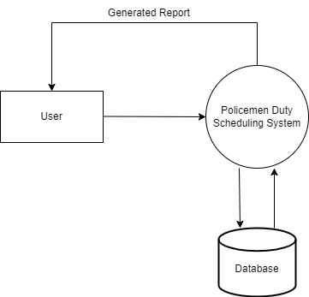

Data Flow Diagram (Level-0)

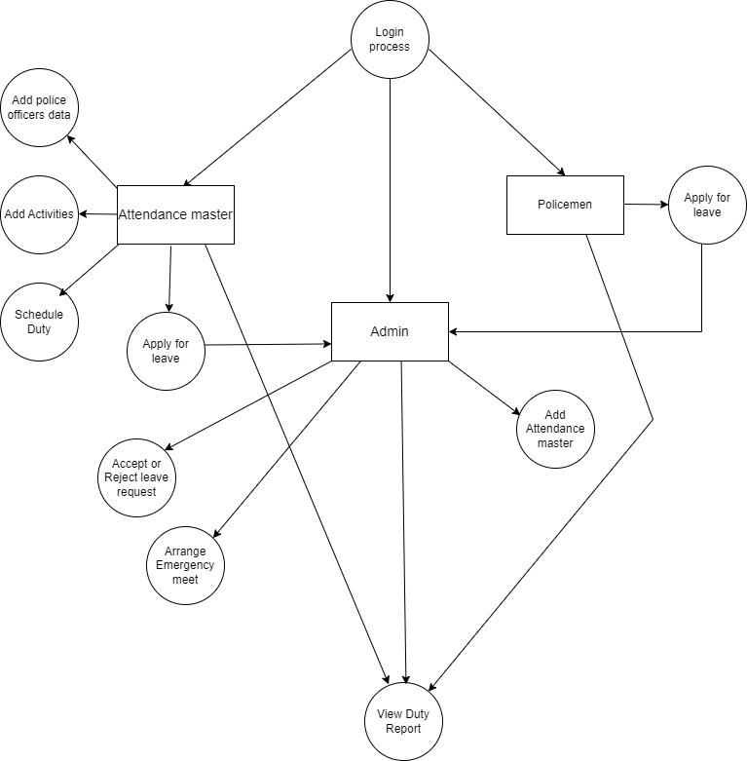

Data Flow Diagram (Level-1)

## ER Diagram

## 

**5.3 Class Diagram**

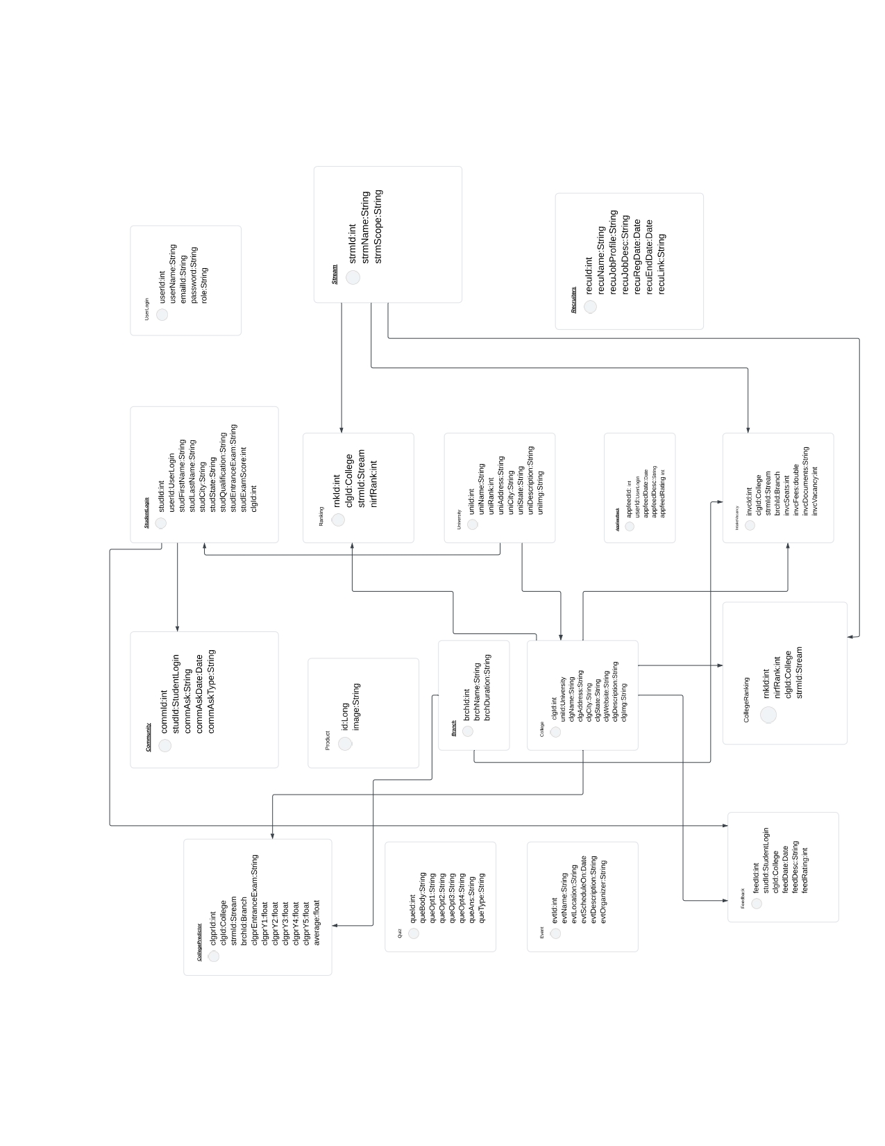

## Sequence Diagram

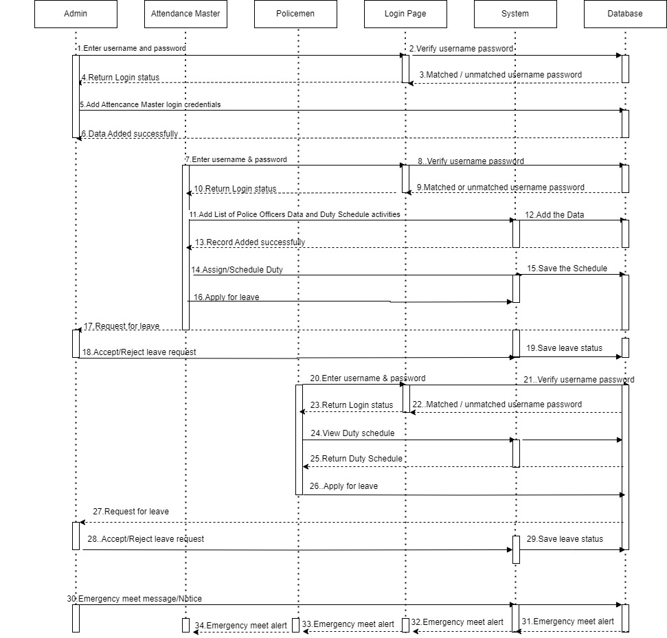

## Activity Diagram

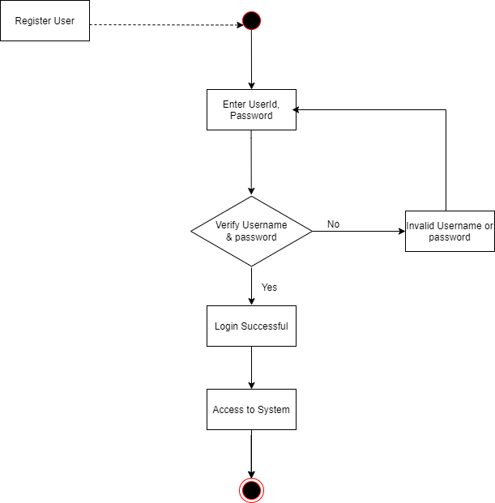

* 1. **Deployment Diagram**

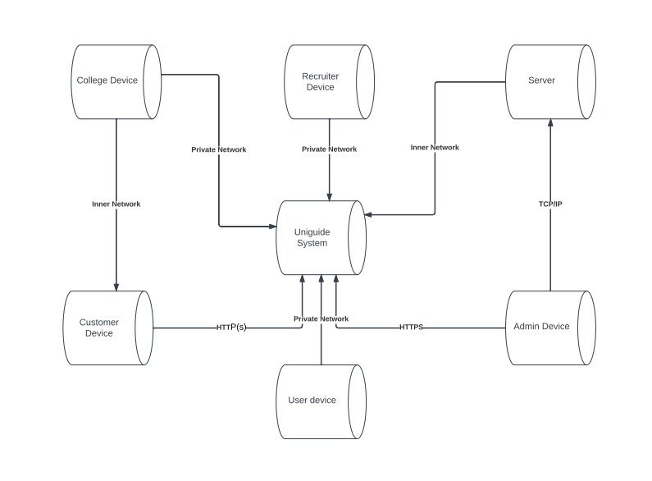

# SCREENSHOTS

## Home Page

This is a welcome page for of Uniguide. Here we have given following components:

 Home

 About Us

 Universities

 Colleges

 Streams

 Test

 College Predictor

 Recruitment

 Account



## Image 1. Home Page

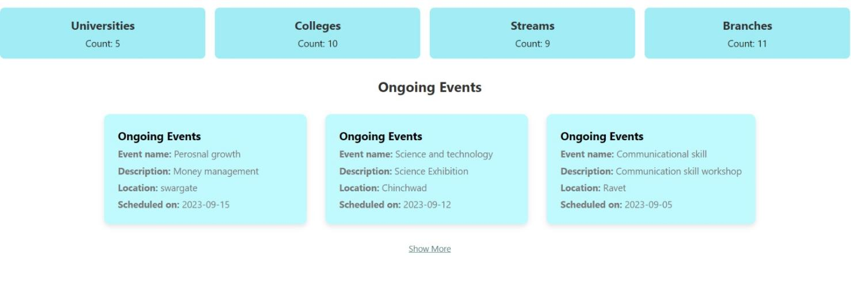

## Image 2. Home Page

## Image 3. Home Page

**2.About Us Page:**

On this page information about website is displayed.



## Image 4. About us Page

**3. Login Page :**

Login page to accept user credentials

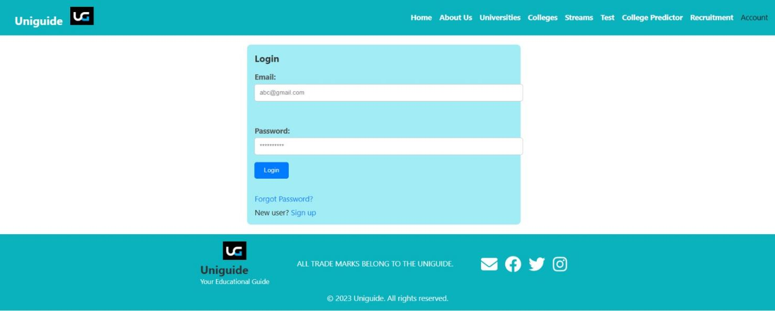

## Image 5. Login Page

**4. Registeration Page :**

Page to register a user.

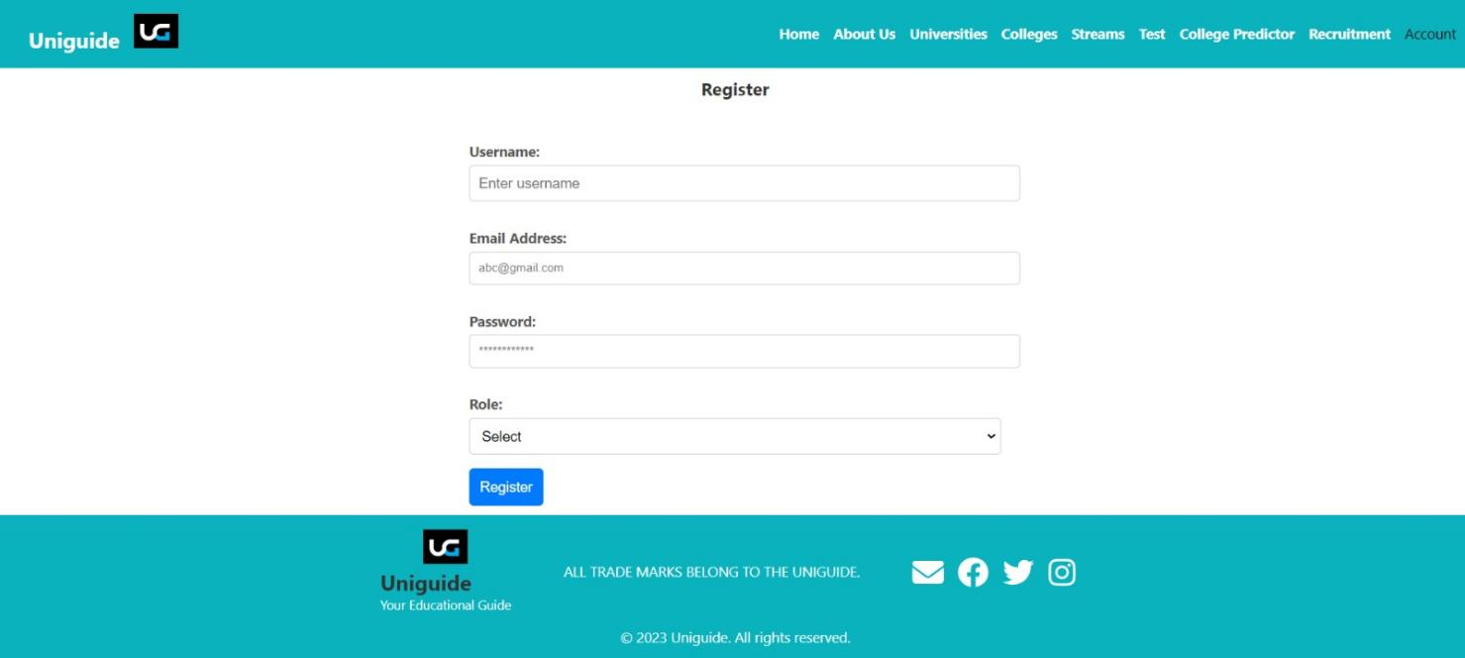

## Image 6. Registeration Page

**5.Forgot Password Page :**

Page to reset user details.

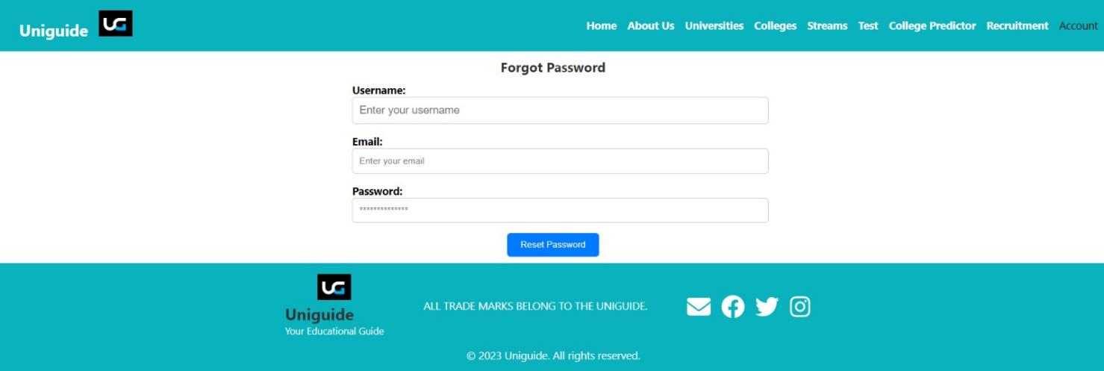

## Image 7. Forgot Password Page

**6.University Page:**

List of all registered universities will be displayed.



## Image 8. University Page

**7.College Page:**

List of all registered colleges is displayed with sort by city, rank options available. Add college button is also available.

## 

## Image 9. College Page

**8.Stream Page:**

All Streams with future scope available.

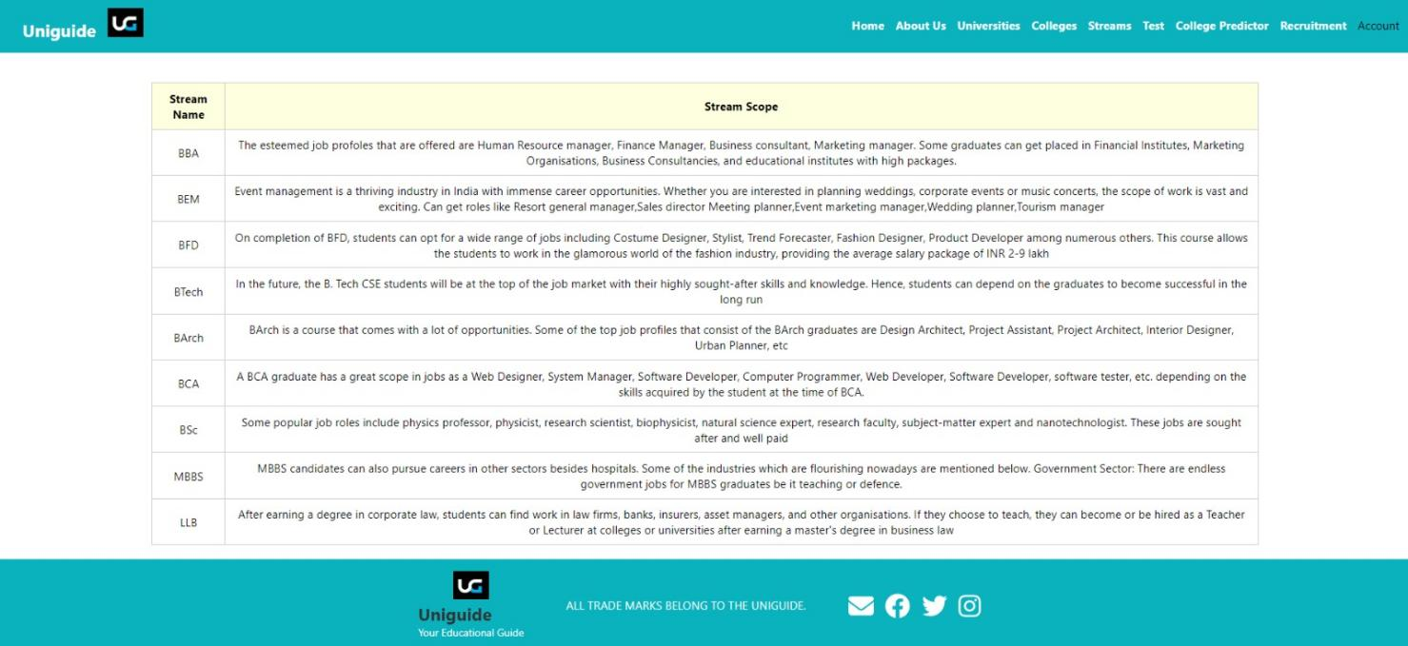

## Image 10. Stream Page

**9.Test Page:**

Inclination test page with question and options.

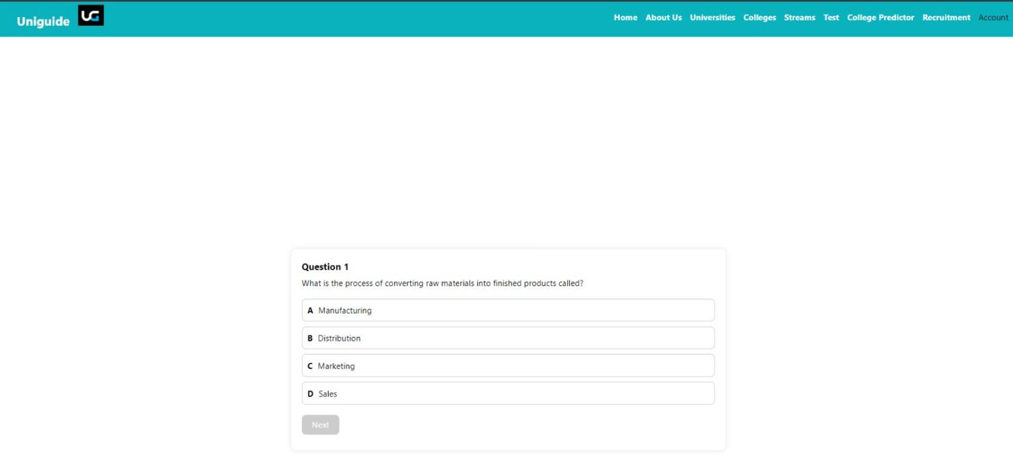

**Image 11. Test Page**

**10.College Predictor Page:**

In this page student has to enter the marks and entrance exam also have to select tolerance value from which all colleges will be displayed within range.



## Image 12. College Predictor Page

**11.Recruiter Page:**

List of all recruitments is displayed with add recruitment button.

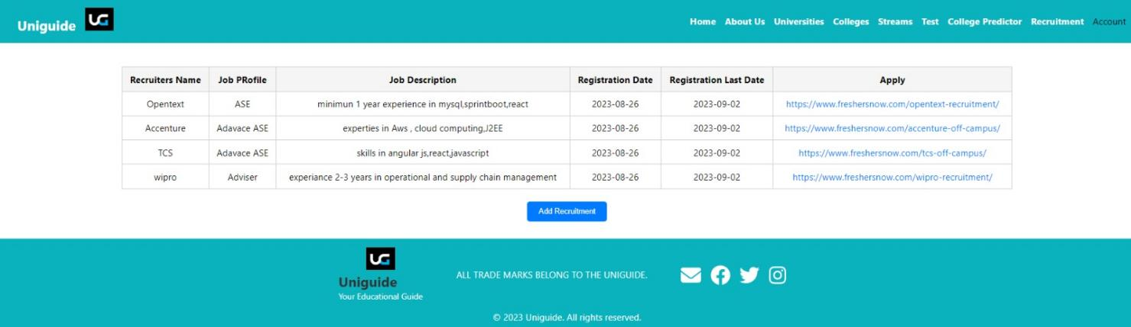

## Image 13. Recruiter Page

**12.Feedback-list Page :**

List of application feedback given by users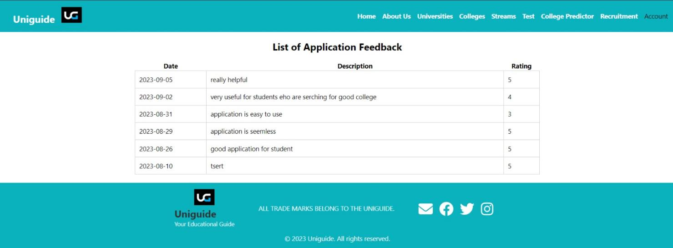

## Image 14. Application Feedback Page

**13.Event-list Page :**

List of all ongoing events.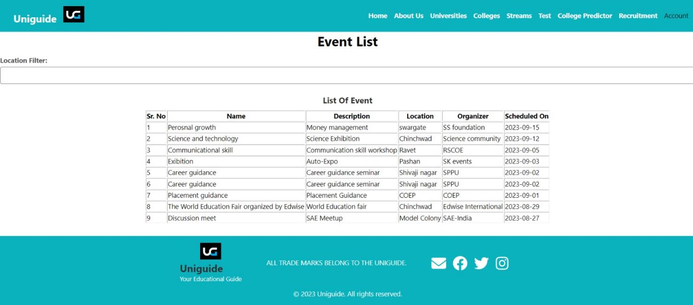

## Image15. Events-List Page

**14.Application-feedback Page :**

Application feedback page to take feedback from user.

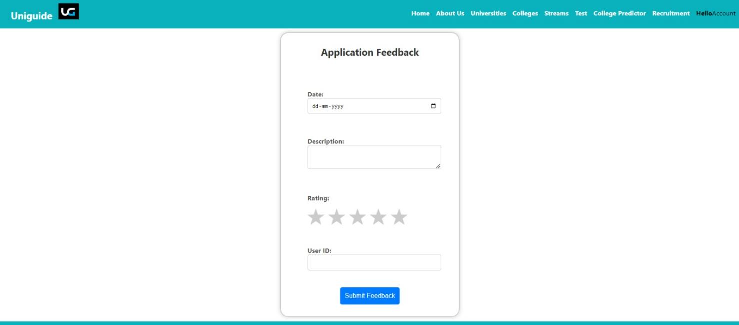

**Conclusion**

In conclusion, UniGuide stands as a pioneering solution in the realm of academic and career guidance. By seamlessly integrating marks and Inclination test marks, it empowers students to embark on a journey of self-discovery, aiding them in making well-informed decisions about their educational and professional trajectories. This comprehensive web application not only assists in identifying suitable career paths but also facilitates a personalized approach to selecting educational institutions that align with individual academic accomplishments. UniGuide is poised to revolutionize how students navigate their futures, offering a powerful tool that nurtures their aspirations and ensures a brighter, more fulfilling tomorrow.